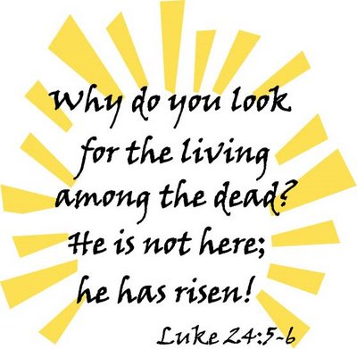
Saint Anselm School
Parent Club Meeting Agenda
April 9, 2024

Call to Order/Opening Prayer

A big Thank You to…

Amanda Sambula & Jackie Finomore for a wonderful morning at Dad & Donuts!

Lisa Hoehnen & Rachel Grano for a super fun middle school GLOW dance!

Lisa Hoehnen& Nicole Romanini for organizing the preschool egg hunts!

Nicole Romanini for running the Spring Flower Sale!

Judy Pistner, Jackie Finomore, Natalie Cherosky & Renee Bitto for helping bake the soft pretzel treat for the Lenten Retreat Day!

Treasurer’s Report: Judy Pistner

Committee Reports:

Scholastic Book Fair: Renee Bitto and Rachel Scott
April 22nd -26th
BOGO
Sign up genius going out for volunteers

Middle School Event: Lisa Hoehnen & Rachel Grano
Whirly Ball on April 26th
Flyer went out with information and waiver

Color Run/Fun Day: Rachel Grano & Emily DeCapite
Thursday, May 9
Stations ideas? Different ones for different grades?

Hospitality: Giovanna DiFranco & Caryn Sczcepinski
Teachers’ Appreciation Week Spring Luncheon
Wednesday May 8th
Food Choice?

Moms and Muffins: Natalie Wlotzko and Katie Jacobs
Friday, May 10, 7:15-8:15, followed by School Mass
Need anything?

Field Day Lunch: Jackie Finomore
Wednesday, May 17 after Field Day
Time to be coordinated with Mr. Montz
Hot dogs, watermelon, popsicles

Fourth of July Parade: Vinka Knott, Tracey Onderdonk & Lindsay Svarovsky
What do we need? Ask for candy before school lets out?
Volunteers to help make the float?

Welcome Back Picnic: Tracey Onderdonk & Need Co-Chair
Location? Date?

Fall Gala: Jen Antoon & Amanda Sambula
Save the Date reviewed
Online donation requests sent
Looking for ways to increase sponsorships/advertisers using our
social media
Next Meeting in May

New Business:
Textbooks request
Ideas for funds
Last day of school
Open Positions for next year Co-Chairs:
Welcome Back Picnic
Mother Son Hayride
Preschool Egg Hunt
Middle School Dance Chair
Welcome Ideas for New Families?

Old Business:

Drive-In Movie Night movie choice
Flower sale

Principal’s Report: Mrs. Rose

Closing Prayer

See following page for Upcoming Important Dates for
the remainder of the School Year!

Important Upcoming Dates:
April 22-26: Scholastic BOGO Book Fair
April 26th: Middle School Event – Whirly Ball
May 7: Parent Club meeting
May 6-10: Teacher Appreciation Week
May 8: Teacher Appreciation Luncheon
May 9: Fun Run
May 10: Moms & Muffins
May 15: Final Day for 3 Yr. Old Preschool
May 15: 8th Grade Dinner
May 16: Final day for 4 year old preschool
May 16: Final day for 8th grade/Clap-Out/8th grade graduation
May 17: Final day for Kindergarten/ Kindergarten graduation
May 17: Drive-In Movie Night
May 17: Fun & Field Day/End of the Year Picnic
May 17: 8th Grade Dinner
May 18: Final Day for 4 Yr. Old Preschool
May 18: Final Day for 8th Grade/Clap-Out/8th Grade Graduation
May 19: Final Day for Kindergarten/Kindergarten Graduation
May 21: Flower Sale Pick up
May 22: Field Day/ Lunch from Parent Club
May 24: Final Day for Grades 1-7 (half day)
May 26: End of the Year Picnic
July 4: Parade! Join us on the St. Anselm Float!

