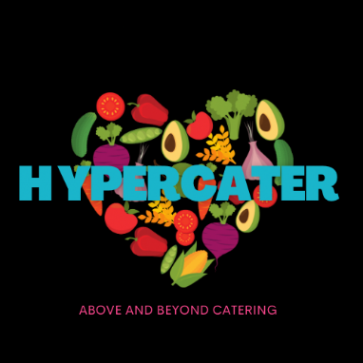

BREAKFAST/BRUNCH

Continental Breakfast
$80 per person
Minimum 15 pax
Gluten free and vegan an extra $2 per person
All dietaries can be accommodated
Creamy Greek yoghurt pot with fruit compote, granola, toasted coconut and berries (GF)
Ham and cheese croissant
Pesto Florentine croissant (V)
Mixed mini muffins
Mixed mini Danishes
Seasonal fruit platter
Add Breakfast sliders for an extra $10 each
Bacon, egg and HP sauce sliders/Grilled haloumi, egg and tomato jam slider (v)

BRUNCH GRAZING
$100 per person
Minimum 15 pax
All dietaries can be accommodated
Assorted breads with condiments for toasting
Hot Selection
Eggs benedict, double smoked ham, baby spinach, poached egg, citrus hollandaise
Smoked salmon additional $2 per person
Souffle style frittata with ricotta, fetta, Swiss brown mushroom, kale
Crispy streaky double smoked bacon
Herb and garlic roasted mushrooms
Oven roasted balsamic basil tomatoes
Sweet potato, cheddar and spring onion bubble & squeak

Cold Selection
Chai bircher pots with Greek yogurt, mango and passion fruit compote
Seasonal fruit salad with a passionfruit dressing
Selection of assorted mini danishes and croissants
Mini banana and coconut muffins
Mini pancakes drizzled with maple & strawberry salsa

SIT DOWN PLATED
$80 per person
Minimum 15 pax
All dietaries can be accommodated

Poached eggs on English muffin, crispy streaky bacon, oven baked tomato, sautéed baby spinach, sweet potato bubble and squeak, citrus hollandaise
Fruit plates with bush honey Greek yoghurt for the table
Breakfast Petit four selection for the table

FRESH SQUEEZED OJ, DELUXE TEA SELECTION, FRESH ROASTED COFFEE, FILTERED WATER
$16 per person

