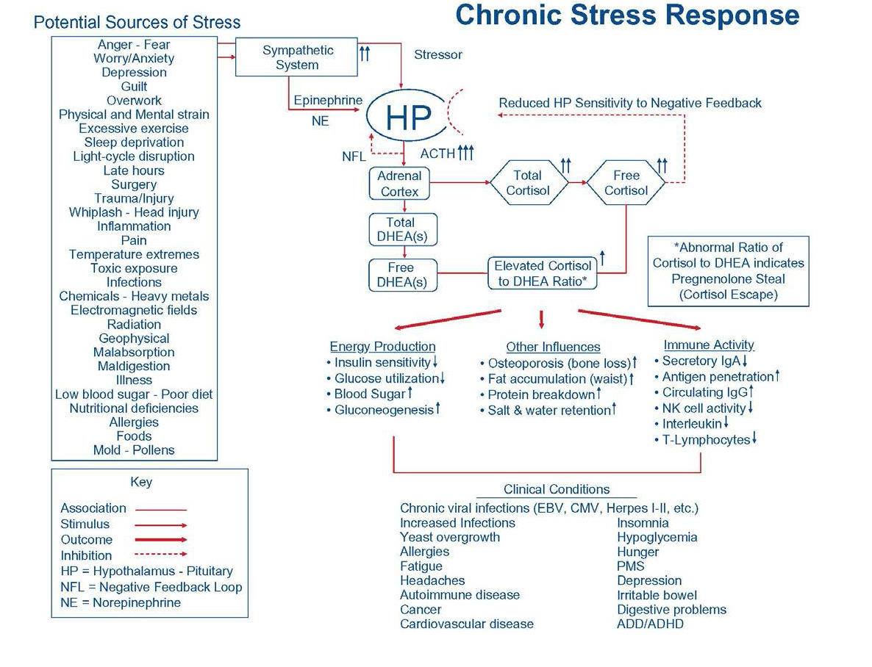
Clinical-JumpStart-Slides-Biohealth.pdf


The Importance of Cortisol and DHEA ratio.