low-FODMAP carbs
(If you have the need to feel FULL )
(choose NON-GMO)

- Brown rice – 1 cup cooked = 3.5 grams of dietary fiber
- Quinoa which is low-FODMAP, a seed (not a grain) and it’s a complete protein. 1 cup cooked = 12 grams of dietary fiber!
- Cooked oats (quick dry). Stick to a 1/4 cup serving = 4 grams of dietary fiber
- Polenta – 1 cup cooked = 7.3 grams of dietary fiber
- Buckwheat Kernels – Stick to a 1/8 cup serving = 2.1 grams of dietary fiber
- Flakes of Corn (gluten free) – 3/4 cup = 4 grams of dietary fiber
Drink plenty of water and eat foods high in vitamins and nutrients like fruits and veggies, lean proteins and healthy fats.
Make sure you have both raw and cooked veggies, as just consuming raw could trigger symptoms of IBS.

Soluble vs. Insoluble Fiber
Fruits and vegetables are the best ways to get your soluble (and insoluble) fiber. There are benefits to both soluble and insoluble fiber, but keep in mind, most HIGH FODMAP foods are made of soluble fiber.
Soluble fiber dissolves in water. It attracts water and form a gel, which slows down digestion. The emptying of your stomach is delayed and soluble fiber makes you feel full.
Low-FODMAP foods with soluble fiber are: blueberries, oranges, eggplant, carrots, grapefruit (1/4 or less), potatoes; oatmeal (1/4 cup), oat bran, brown rice, tofu, flax and sunflower seeds (2 tablespoons), canned chickpeas (1/4 cup) and canned lentils (1/2 cup).
Insoluble fibers do not dissolve in water and they pass through the gastrointestinal tract relatively intact, and speed up the passage of food and waste through your gut. These are great for people with IBS-C. Insoluble fibers are considered beneficial fiber for the gut because of the laxative effect and they add bulk to the diet, helping prevent constipation.
Low-FODMAP foods with insoluble fiber are: seeds (2 tablespoons), nuts (no cashews or pistachios), brown rice, zucchini, celery (1/4 stalk), broccoli (1/2 cup), cabbage (common), tomatoes, carrots, cucumbers, green beans, dark leafy vegetables, grapes, and potato skins.

Good Non-fermentable supplements for constipation: Citrucel, psyllium husk and cellulose

Fiber Supplements HIGH in FODMAPs causing symptoms:

Inulin – mostly obtained from chicory root or Jerusalem artichoke;chicory root extract. Inulin is a HIGH FODMAP.

Beet fiber, corn fiber, soy fiber, citrus fiber

Carrageenan is a water-soluble fiber found in certain types of seaweed.

Guar Gum guar seeds are dehusked, milled and screened to obtain the guar gum. It is used as a thickener and a binder.

Other functional fibers that you will find in foods are: pectin, chitosan, cellulose, methylcellulose, beta-gucans, polydextrose, resistant dextrins,fructooligosaccharides (FOS) used as an alternative sweetener, and acacia fibers.

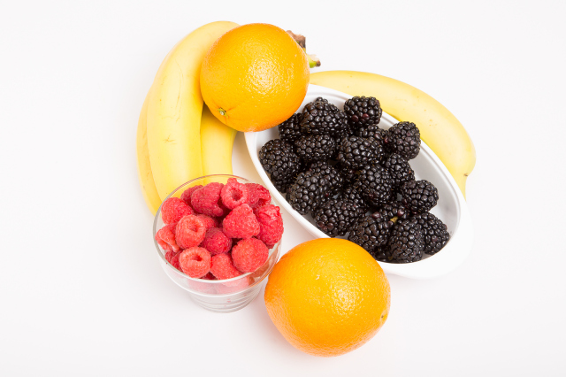

Some Low-FODMAP Fiber Sources:
- Oranges, raspberries, ripe bananas. Everything pictured above is low-FODMAP BUT the blackberries – just 5 are HIGH in FODMAPs
- Corn, potatoes (with skin), carrots, spinach
- Brown rice and brown rice products
- Rice bran (2 tablespoons)
- Oatmeal (1/2 cup cooked)
- Oat bran (2 tablespoons)
- Quinoa
- Nuts and nut butters (one handful or 2 tablespoons–no cashews or pistachios)
- Seeds and seed butters (one handful or 2 tablespoons)
- Canned, drained, lentils (1/2 cup)
- Chia seeds, whole or ground (2 tablespoons)
- Tempeh (3 ounces)
http://fodmaplife.com/

