UPSC CSE Exam Pattern

The Union Public Service Commission (UPSC) Civil Services Examination (CSE) is one of the most prestigious and challenging competitive exams in India. It is conducted annually to recruit officers for various civil services of the Government of India, including the Indian Administrative Service (IAS), Indian Police Service (IPS), Indian Foreign Service (IFS), and other central services. The exam is known for its rigorous selection process and comprehensive coverage of various subjects. Here is an in-depth analysis of the UPSC CSE exam pattern:

Overview of the Exam
The UPSC CSE is conducted in three stages:
A) Preliminary Examination (Prelims)
B) Main Examination (Mains)
C) Personality Test (Interview)
Each stage serves as a filter to eliminate less-prepared candidates and identify those with the highest potential to become effective civil servants.

A) Preliminary Examination
The Preliminary Examination is the first step in the selection process. It consists of two papers, both of which are objective type (multiple choice questions):

1) General Studies Paper I
2) General Studies Paper II (CSAT - Civil Services Aptitude Test)

1) General Studies Paper I
Total Marks: 200
Number of Questions: 100
Duration: 2 hours
Syllabus:
  - Current events of national and international importance.
  - History of India and Indian National Movement.
  - Indian and World Geography - Physical, Social, Economic Geography of India and the World.
  - Indian Polity and Governance - Constitution, Political System, Panchayati Raj, Public Policy, Rights Issues, etc.
  - Economic and Social Development - Sustainable Development, Poverty, Inclusion, Demographics, Social Sector Initiatives, etc.
  - General issues on Environmental Ecology, Biodiversity and Climate Change - that do not require subject specialization.
  - General Science.
2) General Studies Paper II (CSAT)
Total Marks: 200
Number of Questions: 80
Duration: 2 hours
Syllabus:
  - Comprehension.
  - Interpersonal skills including communication skills.
  - Logical reasoning and analytical ability.
  - Decision-making and problem-solving.
  - General mental ability.
  - Basic numeracy (numbers and their relations, orders of magnitude, etc.) - Class X level.
  - Data interpretation (charts, graphs, tables, data sufficiency etc.) - Class X level.
Note: The CSAT paper is of qualifying nature, and candidates need to score a minimum of 33% to pass. The marks obtained in Paper I determine the selection for the Main Examination.

B) Main Examination
The Main Examination is a crucial stage, consisting of nine papers of descriptive/essay type. These papers are designed to test a candidate’s in-depth knowledge and intellectual capabilities. Only those candidates who clear the Preliminary Examination are eligible to sit for the Main Examination.
The written examination consists of 9 papers out of which 2 papers are qualifying in nature. The marks obtained in the remaining 7 papers and the interview test together are considered for making the final merit.

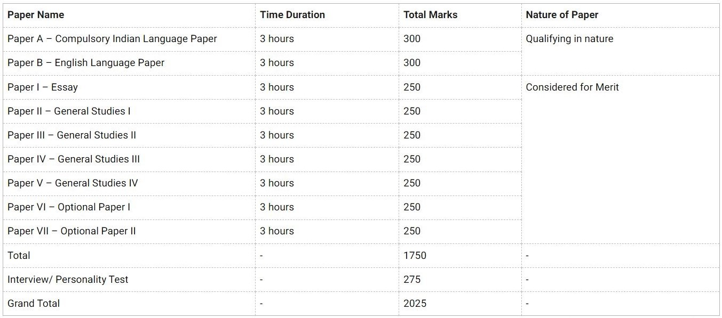

C) Personality Test (Interview)

The UPSC Civil Services Examination (CSE) interview, also known as the Personality Test, is the final stage in the selection process for Indian Administrative Service (IAS) and other civil services. It is a crucial phase, assessing a candidate’s overall personality, suitability for a career in public service, and ability to handle the responsibilities of an administrative role.
Overview
- Duration: Typically, 30-45 minutes
- Total Marks: 275
- Venue: UPSC Office, Dholpur House, New Delhi
- Eligibility: Candidates who qualify the Main Examination

Areas of Evaluation
- Personality and Demeanour: Confidence, Attitude, Posture and body language, Calmness under pressure
- Communication Skills: Clarity of thought, Articulation, Listening skills, Conciseness and coherence in speech
- Intellectual Capacity: Analytical skills, Logical reasoning, Ability to provide balanced and reasoned arguments
- Social Traits: Leadership qualities, Teamwork and cooperation, Empathy and compassion, Interpersonal skills
- Awareness and Knowledge: General awareness, Understanding of socio-economic issues, Current events of national and international importance, Knowledge related to the candidate’s educational background and work experience, Understanding of issues mentioned in the Detailed Application Form (DAF)

