

453 W. Main St. Mt. Orab, OH 45154

P: 937-444-6000 ~ F: 937-444-6001

**Confidential Patient Information**

Date____________

Patients Name: _____________________________________ Main Complaint: ________________________________________________

Address: __________________________________________ Home Phone: ___________________________________________________

City: ________________________ Zip:________________ Cell Phone: ____________________________________________________

SS#: _____________________________________________ Email: ________________________________________________________

Date of Birth: ______________________________________ Marital Status: M S W D

Occupation: _______________________________________ Employer: ____________________________________________________

Were you referred to our office by anyone? ______________________________________________

May we leave messages regarding your personal healthcare information on any answering device,i.e. home answering machines or voicemails? Yes [ ] No [ ]

Are your present systems or condition related to, or the result of an auto collision, work-related injury or other personal injury? (Someone else might be responsible for payment?) ___ Yes ___No

In the In the event that we would need to communicate your healthcare information, to whom may we do so?

Spouse:________________________ Children: _______________________­­­Others: _________________________ No one: [ ]

Family Physician: _______________________________________________ (Note: May we send your health information to this provider **Y / N**)

Person to contact in case of emergency (Name and Phone): ________________________________________________________________

Have you ever been under Chiropractic Care? Y N If so, Who? _________________________________________________________

Have you had any SPINAL X-Rays / MRI’s / CT’s taken in the last year? Y N If so, Where? __________________________________

What operations have you had? _____________________________________________________________ When? _________________

Serious Illness: __________________________________________________________________________ When? _________________

Infectious Diseases: ______________________________________________________________________ When? _________________

Do you have a pace maker? **Y / N** Have you ever had any Hip or Knee Replacements **Y / N**

What medications or drugs are you taking? (check those that apply): Pain Killers ____ Insulin _____ Cholesterol Meds ________

Blood Pressure Meds ___ Muscle Relaxers ___ Birth Control ___ Other: __________________________________

What is your goal in our office? ______________________________________________________________________________________

## LEGAL ASSIGNMENT OF BENEFITS AND RELEASE OF MEDICAL AND PLAN DOCUMENTS

In considering the amount of medical expenses to be incurred, I, the undersigned, have insurance and/or employee health care benefits coverage with the above captioned, and hereby assign at clinic’s request, and convey directly to ***Active Living Chiropractic*** all medical benefits and/or insurance reimbursement, if any, otherwise payable to me for services rendered from such doctor and clinic. I understand that I am financially responsible for all charges regardless of any applicable insurance or benefit payments. I hereby authorize the doctor to release all medical information necessary to process this claim. I hereby authorize any plan administrator or fiduciary, insurer and my attorney to release to such doctor and clinic any and all plan documents, insurance policy and/or settlement information upon written request from such doctor and clinic in order to claim such medical benefits, reimbursement or any applicable remedies. I hereby authorize the doctor to release any and all medical information to other healthcare providers involved in my care including but not limited to my primary care physician. I authorize the use of this signature on all my insurance and/or employee health benefits claim submissions.

I hereby convey to the above named doctor and clinic to the full extent permissible under the law and under the any applicable insurance policies and/or employee health care plan any claim, chose in action, or other right I may have to such insurance and/or employee health care benefits coverage under any applicable insurance policies and/or employee health care plan with respect to medical expenses incurred as a result of the medical services I received from the above named doctor and clinic and to the extent permissible under the law to claim such medical benefits, insurance reimbursement and any applicable remedies. Further, in response to any reasonable request for cooperation, I agree to cooperate with such doctor and clinic in any attempts by such doctor and clinic to pursue such claim, chose in action or right against my insurers and/or employee health care plan, including, if necessary, bring suit with such doctor and clinic against such insurers and/or employee health care plan in my name but at such doctor and clinic's expenses.

This assignment will remain in effect until revoked by me in writing. A photocopy of this assignment is to be considered as valid as the original. I have read and fully understand this agreement.

____________________________________________________ _____________________________

Signature of Insured / Guardian Date

****453 W. Main St. Mt. Orab, OH 45154

P: 937-444-6000 ~ F: 937-444-6001

CASE HISTORY

Patient Name: _________________________________

How long have you had pain? __________years ______________months ________________weeks

On the 4 body diagram below, please indicate where you are experiencing pain or other symptoms:

**A**=Ache **B**=Burning **N**=Numbness **P**=Pins & Needles **S**=Stabbing **O**=Other

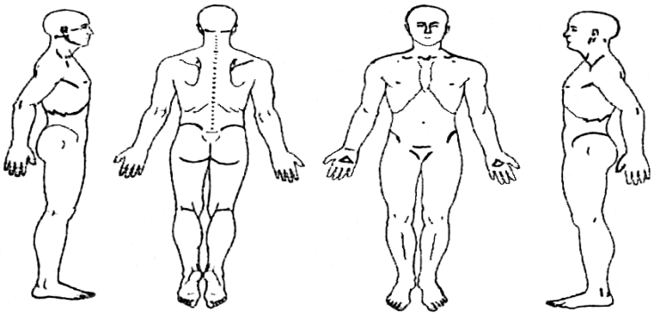

On a scale from 0 to 10 please indicate the severity of your pain from your main complaint: ________

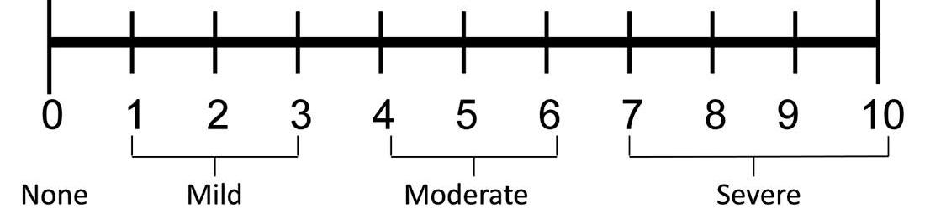

|  |
| --- |
| PAIN SCALE |
|  |

In your own words, please explain what your biggest health concern is:

______________________________________________________________________________________________________________________________

1. How did your symptoms begin? _____________________________________________________________________
2. Have you experienced these before? __________________________________________________________________
3. Do your symptoms radiate? _________________________________________________________________________
4. Has your condition? ____ Improved ____ Gotten Worse ____ Stayed the same since it began
5. Circle the things that make your problems worse:

Bending - Lying - Walking - Standing - Sitting - Movement - Twisting - Lifting - Sleeping

1. Is there anything you can do to relieve the problems? ____No ____Yes Describe: _____________________________

If No, what have you tried that has not helped? _________________________________________________

1. Is this condition interfering with ____ Work ____Sleep ____Daily Routine ____Recreation
2. List any other major injuries you have had, other than those mentioned above: ________________________________

___________________________________________________________________________________________________

1. Any other musculoskeletal problems? ____No ____Yes Neurological problems? ____No ____ Yes

***I certify that the above information is accurate to the best of my knowledge***.

Patient/Guardian Signature _________________________________________________ Date: ______________

 453 W. Main St. Mt. Orab, OH 45154

P: 937-444-6000 ~ F: 937-444-6001

**Terms of Acceptance**

The goal of our office is to enable patients to gain control of their health. To attain this we believe communication is the key. There are often topics that are hard to understand and we hope this document will clarify those issues for you.

Please read the below and if you have any questions please feel free to ask one of our staff members.

**Informed Consent:**

A patient, in coming to the chiropractic doctor, gives the doctor permission and authority to care for the patient in accordance with the chiropractic tests, diagnosis, and analysis. The chiropractic adjustment or other clinical procedures are usually beneficial and seldom cause any problems. In rare cases, underlying physical defects, deformities or pathologies may render the patient susceptible to injury. The doctor, of course, will not give any treatment or care if he/she is aware that such care may be contra-indicated. Again, it is the responsibility of the patient to make it known, or to learn through healthcare procedures what he/she is suffering from: latent pathological defects, illnesses or deformities which would otherwise not come to the attention of the chiropractic physician. The chiropractic doctor provides a specialized, non-duplicating health care service. Your doctor of chiropractic is licensed in a special practice and is available to work with other types of providers in your health care regimen. I understand that if I am accepted as a patient by a physician at Active Living Chiropractic, I am authorizing them to proceed with any treatment that they deem necessary. Furthermore, any risk involved, regarding chiropractic treatment, will be explained to me upon my request.

I have read and fully understand the above statements. I have reviewed the notice of privacy practices (HIPAA) and have been provided an opportunity to discuss my right to privacy. Upon request I will be given a copy.

**Acknowledgement**

**NO SHOW CHARGE**

**A no-show is when a patient misses an appointment without cancelling either by message on-line or by phone. In either case, we will charge the patient a $25.00 missed appointment fee**

I have read and fully understand the above statements. I have reviewed the notice of privacy practices (HIPAA) and have been provided an opportunity to discuss my right to privacy. Upon request I will be given a copy.

Print Name: ______________________________________________

Signature: ________________________________________

Date: __________________________