453 W. Main Street. Mt. Orab, Ohio 45154



937.444.6000 activelivingichiropractic.org

|  |
| --- |
| INTRODUCTION |



|  |  |
| --- | --- |
| MmmEmEDICAL MEDICAL HISTORY |  |

Pregnant Patient Introduction Form



Date: _____________________________

Patient name: _____________________________________________________ Estimated Due Date: ___________________________

Address: _________________________________________________________ Home Phone: _______________________________ ☐



City, State, Zip: ___________________________________________________ Work Phone: _______________________________ ☐

Email address: ____________________________________________________ Cell Phone: ________________________________ ☐

Birth date: __________________ Age_____________ Marital Status: ____________ Check preferred method of contact

Occupation: ______________________ Employer: ____________________________ Employer Address: ________________________________

Spouse/Partner: __________________________ Birth date: __________________ Spouse Occupation: ________________________________

Emergency Contact: ___________________________________________ Phone: _____________________________

Who can we thank for referring you to our office?:_________________________________



Previous Chiropractic Care: ☐ Yes ☐ No Date: _________________ Doctor: ________________________________________

Were X-rays taken: ☐ Yes ☐ No Date: _________________

Please list any/all medications you are taking at this time and precise dosage per day in mg. Please include prescription drugs, over the counter medications, and any vitamins and supplements.

|  |  |  |
| --- | --- | --- |
| 1. | ___________________________________________ | Do you have any known medication allergies? ☐ Yes ☐ No |
| 2. | ___________________________________________ | Please list and explain reaction: ______________________________________ |
| 3. | ___________________________________________ | ___________________________________________________________________ |
| 4. | ___________________________________________ | ___________________________________________________________________ |

* 1. ___________________________________________

1. ___________________________________________
2. ___________________________________________
3. ___________________________________________
4. ___________________________________________
5. ___________________________________________

Please attach additional sheet if necessary.



1



|  |  |  |
| --- | --- | --- |
| PAIN INDICATOR |  |  |

Pregnant Patient Pain Index



Are you currently experiencing any pain or discomfort? ☐ Yes ☐ No

If yes, please answer the following questions:

How long have you had pain? _____________ Years _____________ Months ____________ Weeks

If you are not experiencing pain, but intend to begin chiropractic care as a proactive approach to optimal health and wellness throughout your pregnancy – please go on to page 3.

On the diagram below, please indicate where you are experiencing pain or other symptoms:

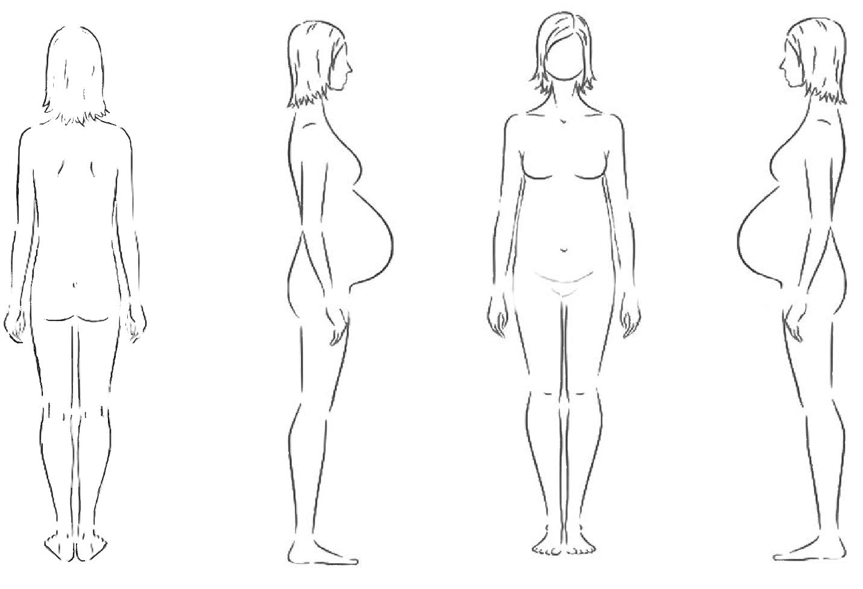

A = Ache **B = Burning** **N = Numbness P = Pins & Needles** **S = Stabbing** **O = Other**



On a scale from 0 to 10 please indicate the severity of your pain: ________

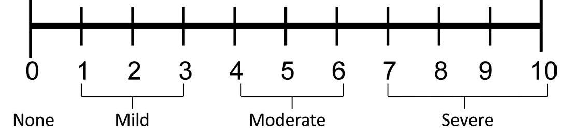

|  |
| --- |
| PAIN SCALE |
|  |

In your own words, please explain what your biggest health concern is: _____________________________________________________________ ______________________________________________________________________________________________________________________________

2

Pregnancy Questionnaire



|  |
| --- |
| PREVIOUS BIRTH EXPERIENCE CONCEPTION & PREGNANCY CURRENT HEALTH CONDITIONS BIRTH PLAN |

|  |
| --- |
|  |

Please circle the correct response. Sign and date when completed.

Is this your first pregnancy? ☐ Yes ☐ No

If no, please tell us about your previous pregnancy and/or birth experience(s) i.e., duration, interventions, etc. ___________________________

____________________________________________________________________________________________________________________________

Do you plan to follow the same plan as your previous delivery? ☐ Yes ☐ No

If no, what would you like to change? ___________________________________________________________________________________________



When is your expected or calculated due date? ______________________________

Did you have any difficulty conceiving? ☐ Yes ☐ No

If yes, please explain: _________________________________________________________________________________________________________

____________________________________________________________________________________________________________________________

When was your last menstrual cycle? ________________________________________

What was your pre-pregnancy weight? ____________________

Current weight? ___________________

What type of exercise(s) are you currently performing? ___________________________________________________________________________

Please tell us about your current diet, and any dietary restrictions: _________________________________________________________________

Have you taken any medications or supplements during your pregnancy? ☐ Yes ☐ No

If yes, please explain: ________________________________________________________________________________________________________

___________________________________________________________________________________________________________________________

Have you had any major emotional stressors during your pregnancy? ☐ Yes ☐ No

If yes, please explain: ________________________________________________________________________________________________________

___________________________________________________________________________________________________________________________

What are your top 3 goals for this pregnancy?

1. __________________________________________________________________________________________________________________
2. __________________________________________________________________________________________________________________
3. __________________________________________________________________________________________________________________

Do you currently have a birth plan? ☐ Yes ☐ No If yes, please explain: __________________________________________________

___________________________________________________________________________________________________________________________

Are you taking any pre-natal or birthing classes? ☐ Yes ☐ No If yes, please explain: ________________________________

___________________________________________________________________________________________________________________________

Who is your OB/GYN or Midwife? _________________________________ Will they be present for the delivery? ☐ Yes ☐ No

3

|  |
| --- |
| BIRTH PLAN CONTINNUED |



|  |
| --- |
| YOUR POST-BRITH PLAN |

Who is your birth provider? _______________________________________ Do you plan to have a doula or birth coach present? ☐ Yes ☐ No If yes, please explain: __________________________________________________________________________________________________________ ______________________________________________________________________________________________________________________________

Do you wish to have a natural vaginal labor and delivery? ☐ Yes ☐ No

If not, what concerns do you have? ______________________________________________________________________________________________

_____________________________________________________________________________________________________________________________

Do you plan on breastfeeding your child? ☐ Yes ☐ No

Is there anything else you’d like to tell us about your pregnancy or birth plan? ☐ Yes ☐ No

If yes, please explain: ___________________________________________________________________________________________________________

What would you like to gain from chiropractic care during your pregnancy? ____________________________________________________________

_______________________________________________________________________________________________________________________________

Are there any burning questions you want to be sure to ask today? ☐ Yes ☐ No

If yes, please explain: ____________________________________________________________________________________________________________

_______________________________________________________________________________________________________________________________

_______________________________________________________________________________________________________________________________

**Communications:**

In the event that we would need to communicate your healthcare information, to whom may we do so?

Spouse: ____________________________________________________

Children: ___________________________________________________

Others: _____________________________________________________

No one: ____

May we leave messages regarding your personal healthcare information on any answering device,

i.e. home answering machines or voicemails? Yes ( ) No ( )

Consent for Purposes of Treatment/Payment & Healthcare Operations



LEGAL ASSIGNMENT OF BENEFITS AND RELEASE OF MEDICAL AND PLAN DOCUMENTS

In considering the amount of medical expenses to be incurred, I, the undersigned, have insurance and/or employee health care benefits coverage with the above captioned, and hereby assign at clinic’s request, and convey directly to **Active Living Chiropractic** all medical benefits and/or insurance reimbursement, if any, otherwise payable to me for services rendered from such doctor and clinic. I understand that I am financially responsible for all charges regardless of any applicable insurance or benefit payments. I hereby authorize the doctor to release all medical information necessary to process this claim. I hereby authorize any plan administrator or fiduciary, insurer and my attorney to release to such doctor and clinic any and all plan documents, insurance policy and/or settlement information upon written request from such doctor and clinic in order to claim such medical benefits, reimbursement or any applicable remedies. I hereby authorize the doctor to release any and all medical information to other healthcare providers involved in my care including but not limited to my primary care physician. I authorize the use of this signature on all my insurance and/or employee health benefits claim submissions.

I hereby convey to the above named doctor and clinic to the full extent permissible under the law and under the any applicable insurance policies and/or employee health care plan any claim, chose in action, or other right I may have to such insurance and/or employee health care benefits coverage under any applicable insurance policies and/or employee health care plan with respect to medical expenses incurred as a result of the medical services I received from the above named doctor and clinic and to the extent permissible under the law to claim such medical benefits, insurance reimbursement and any applicable remedies. Further, in response to any reasonable request for cooperation, I agree to cooperate with such doctor and clinic in any attempts by such doctor and clinic to pursue such claim, chose in action or right against my insurers and/or employee health care plan, including, if necessary, bring suit with such doctor and clinic against such insurers and/or employee health care plan in my name but at such doctor and clinic's expenses.

This assignment will remain in effect until revoked by me in writing. A photocopy of this assignment is to be considered as valid as the original. I have read and fully understand this agreement.

____________________________________________________ _____________________________

Signature of Insured/Guardian Date



**Terms of Acceptance**

The goal of our office is to enable patients to gain control of their health. To attain this we believe communication is the key. There are often topics that are hard to understand and we hope this document will clarify those issues for you.

Please read the below and if you have any questions please feel free to ask one of our staff members.

**Informed Consent:**

A patient, in coming to the chiropractic doctor, gives the doctor permission and authority to care for the patient in accordance with the chiropractic tests, diagnosis, and analysis. The chiropractic adjustment or other clinical procedures are usually beneficial and seldom cause any problems. In rare cases, underlying physical defects, deformities or pathologies may render the patient susceptible to injury. The doctor, of course, will not give any treatment or care if he/she is aware that such care may be contra-indicated. Again, it is the responsibility of the patient to make it known, or to learn through healthcare procedures what he/she is suffering from: latent pathological defects, illnesses or deformities which would otherwise not come to the attention of the chiropractic physician. The chiropractic doctor provides a specialized, non-duplicating health care service. Your doctor of chiropractic is licensed in a special practice and is available to work with other types of providers in your health care regimen. I understand that if I am accepted as a patient by a physician at Active Living Chiropractic, I am authorizing them to proceed with any treatment that they deem necessary. Furthermore, any risk involved, regarding chiropractic treatment, will be explained to me upon my request.

**Acknowledgement**

I have read and fully understand the above statements. I have reviewed the notice of privacy practices (HIPAA) and have been provided an opportunity to discuss my right to privacy. Upon request I will be given a copy.

**NO SHOW NO CALL CANCELLATON POLICY**

A no-show is when a patient misses an appointment without cancelling either by a message on-line or by phone. A charge of $25 missed appointment fee will be applied to your account.

Print Name: ______________________________________________

Signature: ________________________________________ Date: __________________________

