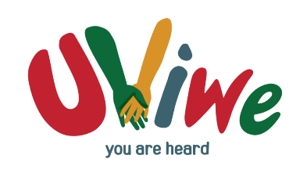
Uviwe Child & Youth Services
2023 ECD MONTHLY FEES
Dear Parents
ECD FEE STRUCTURE FOR 2023 FOR ALL UVIWE ECD CENTRES

Uviwe Child & Youth Services strive to provide a safe space where your child will receive adequate nutrition, a full educational programme and the opportunities to optimally grow and develop.

We are working hard to secure the support from funders but, we also rely heavily on
every parent’s commitment and responsibility to pay their child’s fees. As you are aware, our ECD centres do not receive any subsidy from government and the sustainability of the centre is dependent on paid school fees and successful fundraising activities. To assist us with providing your child(ren) with quality education, the fee structure for 2023 is set out below:

STANDARD FEE STRUCTURE FOR 2022 | Explanation
Registration fee per child R200.00 | This payment must be made with your application to secure your child’s enrollment. Registration fees must be paid on/before 9 December 2022. Registrations open on 17 October 2022.
Monthly fee per child R700.00 | For R700.00 per month, your child will get the following:  - 2 nutritional meals per day  - Daily educational programme inclusive of activities to stimulate learning and optimal development  - A safe, well maintained environment  - Top-up of stationery throughout the year

PAY YOUR CHILD’S FEES ELECTRONICALLY - OR DO A CASH DEPOSIT AT ANY FNB BRANCH.
Bank account details:

Name: Uviwe Child & Youth Services
Bank: FNB (First National Bank) Account type: Cheque Account Account number: 62569785771
Branch: Greenacres (250 655)

Reference – it is of utmost importance that you tell us who you are when you make your payment via EFT. If there is no information we will not be able to know that your child’s fees have been paid. Always use the following information when you do a cash deposit at any bank, or when you do an electronic transfer:

YOUR CHILD’S NAME & SURNAME ( CRECHE’S NAME) For example: Willy Wonker (Gelvandale)

