

**APPLICATION FOR CARE AT Total Health Chiropractic, PSC**

Today’s Date: ___________Primary Care Provider _______________________HRN: _______________________

**Is your problem the result of ANY type of accident, Personal Injury Case or Workers Compensation Incident?** 🞏 Yes, 🞏 No Identify any other injury(s) to your spine, minor or major, that the doctor should know about:________________________________

**PATIENT DEMOGRAPHICS**

Name: ___________________________________________ Birth Date: _____-_____-_____ Age: _______ 🞏 Male 🞏 Female

Address: _________________________________________ City: _________________________________ State: _____ Zip: _______________

E-mail Address: _____________________________ Phone Number: ____________________Social Security#:________________

Marital Status: **❑** Single **❑** Married **❑** Widowed **❑** Divorced Do you have Insurance: **❑** Yes **❑** No

Employer: ________________________________________ Occupation: ________________________________________________________

Spouse’s Name/Date of Birth _________________________________________ Spouse’s Employer ___________________________________

Name of Emergency Contact: ______________________ Contact Number: ___________________Relationship: _________________________

Guarantor (legal guardian): ____________________ Date of Birth : ___________________ Social Security #: ___________________________

**HISTORY of COMPLAINT**

Please identify the condition(s) that brought you to this office: Primarily: _________________________________________________________

Secondarily: __________________________ Third: _____________________________ Fourth: ______________________________________

**\*Fifth: Circle if you suffer pain with any of these: Wrist Elbow Shoulders TMJ(Jaw Pain) Ankle/Feet Knee Hip**

On a scale of **1** to **10** with **10** being the worst pain and **zero** being no pain, rate your above complaints by c***ircling the number*:**

**Primary** or chief complaint is : 0 - 1 - 2 - 3 – 4 – 5 – 6 – 7 – 8 – 9 – 10

**Second** complaints is : 0 - 1 - 2 - 3 – 4 – 5 – 6 – 7 – 8 – 9 – 10

**Third** complaint: : 0 - 1 - 2 - 3 – 4 – 5 – 6 – 7 – 8 – 9 – 10

**Fourth** complaint: : 0 - 1 - 2 - 3 – 4 – 5 – 6 – 7 – 8 – 9 – 10

**Fifth** Complaint: : 0 - 1 - 2 - 3 - 4 - 5 - 6 - 7 - 8 - 9 - 10

When did the problem(s) begin? ____________________ When is the problem at its worst? 🞏 AM 🞏 PM 🞏 mid-day 🞏 late PM

How long does it last? 🞏 It is constant **OR** 🞏 I experience it on and off during the day **OR** 🞏 It comes and goes throughout the week

**How did the injury happen?____________**

**C**ondition(s) ever been treated by anyone in the past? 🞏No 🞏 Yes **If yes,** when: _____ by whom? ____________________________________

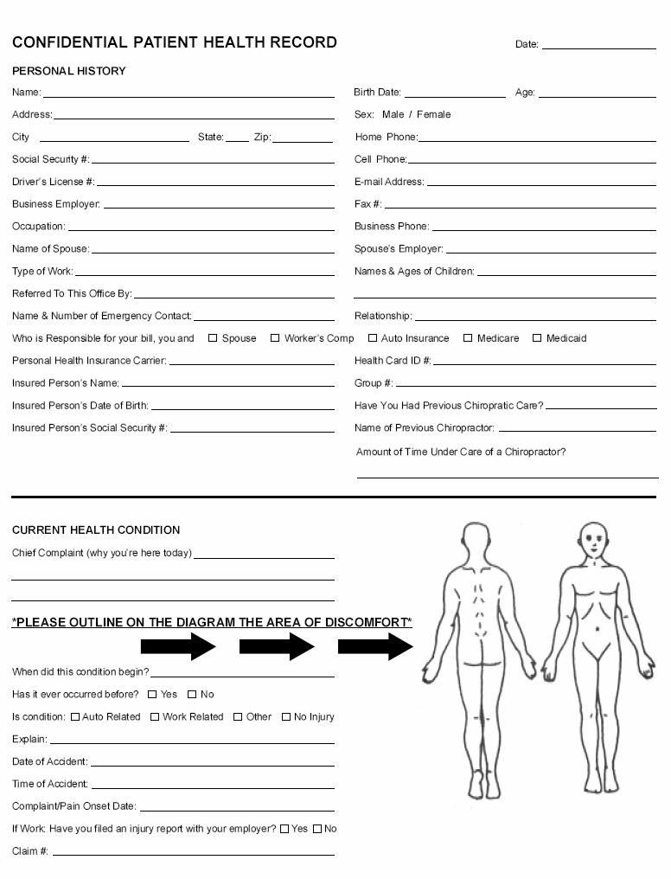How long were you under care: ____________ What were the results? ________________________________________________________

Name of Previous Chiropractor: _______________________________ **🞏 N/A**

**\*PLEASE MARK** the areas on the Diagram with the following **letters** to describe your symptoms:

**R = R**adiating **B** **= B**urning **D =** **D**ull **A =** Aching **N = N**umbness **S =** **S**harp/ **S**tabbing **T= T**ingling

What makes symptoms feel worse? _____________________________

What relieves your symptoms? _________________________________

_____________________________________________________________________________________________________________________

**OFFICE USE: WEIGHT: L_____ R_____ TOTAL_____ BP/HR: _________ Estim: Y/N X-ray: C/S T/S L/S Therapeutic Exercise : Y/N**

Please identify 3 or 4 key values that your current condition is affecting your ability to carry out that are routinely part of your life:

|  |  |  |  |  |
| --- | --- | --- | --- | --- |
| **Activity** |  |  |  |  |
|  | No Effect | Painful (can do) | Painful (Limits) | Unable to Perform |
|  | No Effect | Painful (can do) | Painful (Limits) | Unable to Perform |
|  | No Effect | Painful (can do) | Painful (Limits) | Unable to Perform |
|  | No Effect | Painful (can do) | Painful (Limits) | Unable to Perform |

**PAST HISTORY**

Have you suffered with any of this or a similar problem in the past? ❑ No ❑ Yes **If yes** how many times? ________ _ When was the last episode? _____________________ How did the injury happen?____________

Other forms of treatment tried: 🞏 No 🞏 Yes **If yes,** please state **what** type of treatment: _________________________________, and whoprovided it: _________________________ **How long ago? _______**What were the results. 🞏 Favorable 🞏 Unfavorable🡪 please explain. ____________________________________________________________________ ____________________________________

Please identify any and all types of jobs you have had in the past that have imposed any physical stress on you or your body: ______________________________________________________________________________________________________________

**Please mark P** for **Past** condition**, C** for **Current** condition

___ Headache ___ Pregnant (Now) ___ Dizziness ___ Prostate Problems ___ Ulcers

___ Neck Pain ___ Frequent Colds/Flu ___ Loss of Balance ___ Impotence/Sexual Dysfun. ___ Heartburn

___ Jaw Pain, TMJ ___ Convulsions/Epilepsy ___ Fainting ___ Digestive Problems ___ Heart Problem

___ Shoulder Pain ___ Tremors ___ Double Vision ___ Colon Trouble ___ High Blood Pressure

___ Upper Back Pain ___ Chest Pain ___ Blurred Vision ___ Diarrhea/Constipation ___ High Cholesterol

___ Mid Back Pain ___ Pain w/Cough/Sneeze ___ Ringing in Ears ___ Menopausal Problems ___ Asthma

___ Low Back Pain ___ Foot or Knee Problems ___ Hearing Loss ___ Menstrual Problem ___ Difficulty Breathing

___ Hip Pain ___ Sinus/Drainage Problem ___ Depression ___ PMS ___ Lung Problems

___ Back Curvature ___ Swollen/Painful Joints ___ Irritable ___ Bed Wetting ___ Kidney Trouble

___ Scoliosis ___ Skin Problems ___ Mood Changes ___ Learning Disability ___ Gall Bladder Trouble

___ Numb/Tingling arms, hands, fingers ___ ADD/ADHD ___ Eating Disorder ___ Liver Trouble

___ Numb/Tingling legs, feet, toes ___ Allergies ___ Trouble Sleeping ___ Hepatitis (A,B,C)

***___ Broken Bone ___Dislocations ___ Tumors ___Rheumatoid Arthritis ___ Fracture***

***___Disability ___Cancer ___ Heart Attack ___Osteo Arthritis ___ Diabetes***

***___Cerebral Vascular ___Other serious conditions: ______________________***

**PLEASE identify** **ALL PAST** and any **CURRENT** conditions:

|  |
| --- |
| **HOW LONG AGO TYPE OF CARE RECEIVED BY WHOM** |
| **INJURIES 🡪** |
| **SURGERIES 🡪** |
| **CHILDHOOD DISEASES🡪** |
| **ADULT DISEASES 🡪** |

**List Prescription & Non-Prescription drugs you take**:_______________________________________________________

__________________________________________________________________________________________________

__________________________________________________________________________________________________

**Patient Signature_____________________________________** Date_____________

**SOCIAL HISTORY**

**1. Smoking/Tobacco**: ❑cigars ❑pipe ❑cigarettes ❑Chew/Dip 🡪 How often? ❑ Daily ❑ Weekends ❑ Occasionally ❑ Never

**2. Alcoholic** **Beverage**: consumption occurs 🡪 ❑ Daily ❑ Weekends ❑ Occasionally ❑ Never

**3. Recreational Drug use**: ❑ Daily ❑ Weekends ❑ Occasionally ❑ Never

**FAMILY HISTORY**:

**1.** Does anyone in your family suffer with the same condition(s)? ❑ No ❑ Yes

**If yes whom**: ❑ grandmother ❑ grandfather ❑ mother ❑ father ❑ sister’s ❑ brother’s ❑ son(s) ❑ daughter(s)

Have they ever been treated for their condition? ❑ No ❑ Yes ❑ I don’t know

**2. Any** other hereditary conditions the doctor should be aware of. ❑ No ❑Yes: __________________________

***Whom may we thank for referring you to this office 🡪 _______________________________________?***

I hereby authorize payment to be made directly to Total Health Chiropractic, PSC for all benefits which may be payable under a healthcare plan or from any other collateral sources. I authorize utilization of this application or copies thereof for the purpose of processing claims and effecting payments, and further acknowledge that this assignment of benefits does not in any way relieve me of payment liability and that I will remain financially responsible to Total Health Chiropractic, PSC for any and all services I receive at this office.

___________________________________ _____ - _____ - _____

**Patient or Authorized Person’s Signature Date Completed**

**____________________________________ ______ - ______ - _____**

**Doctor’s Signature Date Form Reviewed**



CURRENT: GOAL: