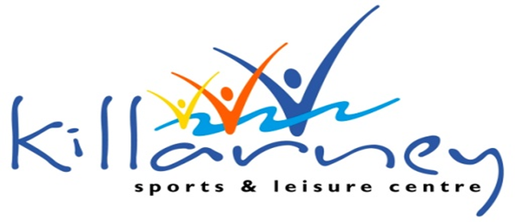

Child Safeguarding Statement

Killarney Sports & Leisure Centre is committed to providing a leisure and work environment that places the safety and welfare of children above all other considerations.

We aim to ensure this continues and to protect the safety and welfare of all children who come to our centre. All allegations of child abuse will be dealt with promptly, seriously, sensitively and confidentially.

Adopting principles of good practice in relation to child protection and safeguarding will ensure that the organisation will help to create an environment in which children are listened to, given a sense of belonging, and kept safe; parents/guardians are supported and encouraged; and staff and volunteers who work with children and young people are supported and protected.

The Coral Leisure Child Protection and Safeguarding Policy has been adapted from “Our Duty to Care” (Dept. of health and children). Coral Leisure are bound to:

Our Child Safeguarding Statement has been developed in line with requirements under the Children First Act 2015, the Children First: National Guidance, and Tusla Child Safeguarding: A Guide for Policy, Procedure and Practice.
We have all relevant procedures including a risk assessment, the following procedures support our intention to safeguard children while they are availing of our service:
- Procedure for the management of allegations of abuse or misconduct against workers/volunteers of a child availing of our service
- Procedure for the safe recruitment and selection of workers and volunteers to work with children
- Procedure for provision of and access to child safeguarding training and information, including the identification of the occurrence of harm
- Procedure for the reporting of child protection or welfare concerns to Tusla
- Procedure for appointment and responsibilities of a Designated Liaison Person
- All procedures listed are available upon request.

We recognise that implementation is an ongoing process. Our service is committed to the implementation of this Child Safeguarding Statement and the procedures that support our intention to keep children safe from harm while availing of our service.

This Child Safeguarding Statement will be reviewed on 01st June 2023, or as soon as practicable after there has been a material change in any matter to which the statement refers.

Signed: __Helena Hammond_
Helena Hammond
General Manager
Killarney Sports & Leisure Centre

For queries, please contact Relevant Person under the Children First Act 2015.

