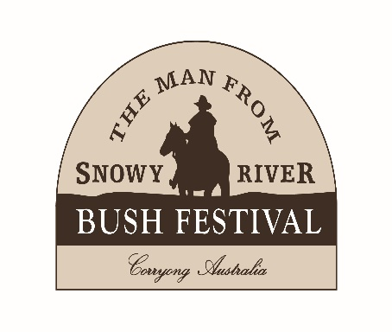
2024 VICTORIAN BUSH POETRY CHAMPIONSHIPS
11th-14th April
ADULT WRITTEN ENTRY FORM
Entries Close Thursday 29th February 2024

NAME:

ADDRESS:

POSTCODE: EMAIL:

MOBILE: HOME:

Entry Fee: $10.00 per poem, up to three entries in Sect 1 & 2 (Males & Females judged together).
(Typed, double spaced, 1 side A4 paper only. 3 copies ea. poem with cover sheet. No name on poem. Max 120 lines).
Please circle “CRITIQUE” for a critique of your poem by Senior judge Graeme Johnson. A fee of $10.00 per poem applies. (Critiques will be posted to contestants post festival).

Judging Sheets for Sections 1 & 2 can be found at www.abpa.org.au/competitions.html

WRITTEN SECTIONS

SECTION ONE: VBPC Open Written Original Serious - Silver Brumby Poetry Award
1st - $150 & Trophy 2nd- $70 3rd - $30

1. POEM TITLE: CRITIQUE

2. POEM TITLE: CRITIQUE

3.POEM TITLE: CRITIQUE

SECTION TWO: VBPC Open Written Original Humorous - Corryong Larrikin Award
1st - $150 & Trophy 2nd- $70 3rd - $30

1. POEM TITLE: CRITIQUE

2. POEM TITLE: CRITIQUE

3. POEM TITLE: CRITIQUE

VBPC Overall Written Champion - $100
VPBC Novice Written Champion – $50
Determined by highest aggregate scores. No entry fee.

AW. PAGE 1/2

TERMS AND CONDITIONS OF ENTRY
- Entrants should be prepared to provide a photo and details for publication if required.
- We reserve the right to publish, record or reproduce work submitted, Copyright ©, is retained by the writer.
- We reserve the right to alter the program if necessary (at any time).
- Judges and anyone paid by the MFSR Bush Festival are ineligible for prizes in Sections 1 & 2
- Judge’s decisions in the Written Sections are final and no correspondence (either verbal or written) or harassment of any judge or official (by contestants) will be accepted or tolerated.

DECLARATION
- I have read and agree to abide by the Terms and Conditions of Entry. Entries are my own work and have not won me a 1st prize at any Victorian State or ABPA National Championships.
- I ALLOW / DO NOT ALLOW my work (© mine) to be used for Festival promotion (please circle).
- I declare that Poetry is (please circle) HOBBY OR My ABN is:
- I declare my status is (please circle) OPEN NOVICE
- Novice: Gained no more than 2 x 1st places in any competition in 2 consecutive years.

Signature: ______________________________________ Date: ____________

ENTRY FEES
I enclose completed entry form and payment of:
Entries: ($10 ea.) ______________Critiques: ($10 ea.) ___________Total: ______________

Payment can be made by:
Direct Deposit:
Account Name: MFSRBF Income Account
BSB: 633 000 Account Number: 1536 14573 Reference: Your surname & ‘Poet’ (e.g. Martin, Poet).

Return entry form, & 3 copies of each poem to:
2024 MFSR Written Bush Poetry Competition
P.O. Box 655, West Ryde, NSW, 1685
Email: TheRhymerfromRyde@bigpond.com

EXTRA INFORMATION
If you would like results mailed to you, please include A4 sized, stamped, self-addressed envelope (2 x $1.50 stamps).
Judges’ assessment sheets will be posted to contestants after the conclusion of the festival.

All sections held Friday night, Saturday and Sunday at the Lions Youth Hall/Banjo’s Block. All awards presented on Sunday afternoon.
Programs, when available, can be purchased at the festival or accessed at www.bushfestival.com.au

If you have any questions, please contact the Assistant Poetry Events Manager Graeme Johnson on 0419415137.
AW. PAGE 2/2

